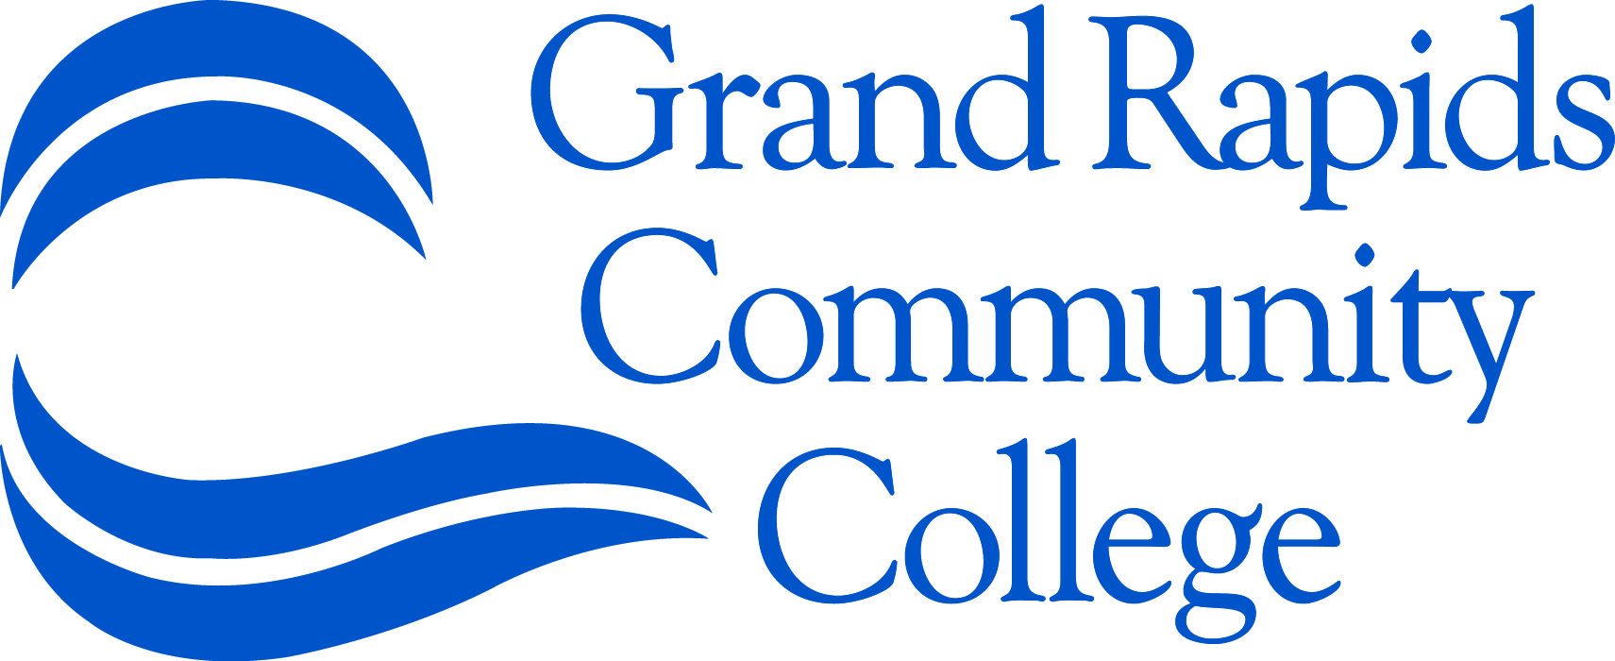 Forensic Chemistry Summer Camp

The Physical Sciences Department at Grand Rapids Community College in collaboration with the National Science Foundation (DUE -1140509) is offering two Forensic Chemistry Camps during the summer of 2013. The goal of the camps is to provide Grand Rapids area high school students who have an interest in science with the opportunity to use analytical instrumentation in an inquiry based forensic chemistry experience. As part of the camp students will use gel electrophoresis, infrared (IR) spectroscopy, gas chromatography-mass spectrometry (GC-MS) and other methods of analysis to find the perpetrator of a simulated arson crime. Some of the instruments that will be used in this analysis are pictured below. The camps will be held in the Science Center July 8th-12th and July 15th-19th from 9:00 a.m. to 2:30 p.m. Enrollment is limited to 16 students per camp.

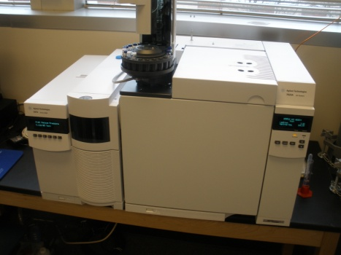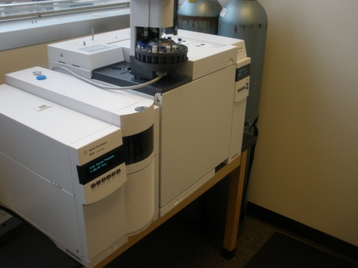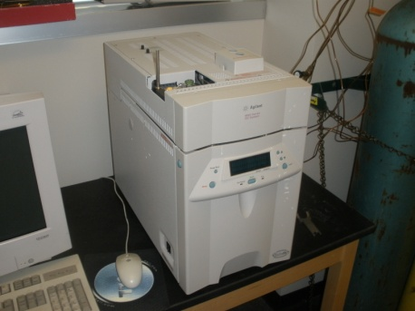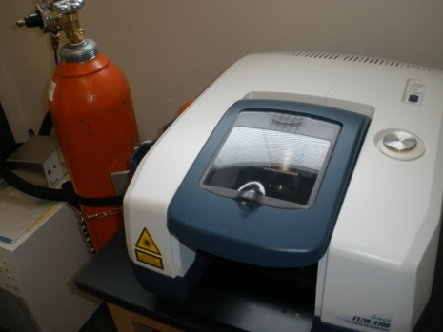
GC - MS instrument GC instrument FT-IR instrument

To apply for the Forensic Chemistry Summer Camp please complete the application form and permission statements on the back and write a 300-400 word essay that addresses why you are interested in science, why you would like to attend this camp and what role you think science will play in your future career.
Submit the application, permission statements and essay to Jennifer Batten, Physical Sciences Department, GRCC, 143 Bostwick Ave. NE, Grand Rapids, MI 49503. Applicants will be selected based on their essay. There is no charge for this summer camp, but if you are selected and later decide that you cannot attend, please let us know so that another student can be enrolled.

For more information please contact Dr. Jennifer Batten at jbatten@grcc.edu or Dr. Bernard Liburd at bliburd@grcc.edu.

This material is based on work supported by the National Science Foundation under grant number DUE-1140509.
Name_______________________________________________________ Parent/Guardian name________________________________________
Address_____________________________________________________ Phone number_______________________________________________
Parent/Guardian Email_________________________________________ Emergency Contact___________________________________________
Emergency Phone_____________________________________________ Grade______________________________________________________
School______________________________________________________ Science Teacher______________________________________________

Preferred camp date: July 8-12 only July 15-19 only July 8-12 preferred July 15-19 preferred
Allergy/Medical/ Physical Conditions or Concerns____________________________________________________________________________________________

Photographic release: I consent and agree that Grand Rapids Community College and its staff have the right to use photographs, videos or audio recordings of my child,_____________________________________________ in educational or promotional materials. I further consent that my child’s name and identity may be revealed therein or by descriptive text or commentary. I release to the GRCC staff all rights to publish or distribute by means of print publication or internet the photographs, videos or audio recordings of my child. I waive my rights, claims or interests I may have to control the uses of my photographs, video or audio recordings of me, and agree that any uses described herein may be made without compensation or additional consideration of me.
_____________________________________________________________________________________________________________________________________
Parent Name Signature Date

Meals: Students taking part in this camp must provide their own meals and snacks. Students may bring their lunch or can go to the Raider Grille cafeteria (Student Center) or Subway (Main Building). We imagine that students would go to lunch in groups. In order to go to the cafeteria or Subway, parents must provide written permission.

I give my child, __________________________________, permission to leave the Science building for the purpose of eating lunch at the Raider Grill or Subway.
_____________________________________________________________________________________________________________________________________
Parent Name Signature Date

Safety: The faculty and staff at GRCC make every effort to ensure safety in the laboratory. As part of ensuring a safe working environment, the following dress code will be strictly enforced:
- Students must wear goggles (provided) whenever they work in the laboratory.
- Students must wear pants or skirts that are mid calf length or longer. Shorts are not permitted.
- Students must wear shoes that cover the entire foot. Sandals, flip-flops, open-back clogs, ballerina shoes are not permitted.

I understand that my child, ______________________________________will not be able to participate in the laboratory activities if he/she is not dressed properly.
_____________________________________________________________________________________________________________________________________
Parent Name Signature Date Student signature

